**Report for HCI Lab3**

Quan Deng

School of Software Engineering

Tongji University

Shanghai,China, E-mail

[1953871@tongji.edu.cn](mailto:1953871@tongji.edu.cn)

**Task 1. Describe a data analysis task for the chosen dataset (objectives, characteristics of the dataset, etc);**

This assignment requires us to visualize a dataset, which is widely used in data mining, artificial intelligence and big data technologies, and I chose Google's App Information dataset. It provides statistics on all apps between 2010 and 2018 in various aspects, including age appropriateness, number of downloads, time online, system requirements, number of reviews, etc. I think the difficulty of this assignment is to understand the programming architecture of dash and the complex API of plotly library and the processing logic of embedded data.

I intend to use this dataset to show app characteristics for different age groups, which can be filtered for different categories, paid or free, and different statistical times as needed. The distribution of reviews and ratings, system requirements and software size of these APPs are counted in a certain group of APPs with appropriate age characteristics, the former is the user attribute of the software and the latter is the hard attribute of the software.

The dataset uses ANSI encoding rules, so some Chinese characters are garbled; also the dataset has misplaced attributes, we delete these wrong entries; in order to unify the display software size, we set the unit as MB and perform unit conversion on kB entries. In order to get the data we want to display, we keep using With, Or, Not operations on the data.

The filtering of app types in the project allows to select all and specific types, and the filtering of price allows to select all, paid and free. If both select all, the age-appropriate statistics are also carried out on all data sets, and the rating-reviews graph and system requirements-software size graph display data on all age-appropriate categories by default, and the rating-reviews graph and system requirements-software size graph display statistics on the corresponding age stage when the bar chart corresponding to a specific age-appropriate is clicked.

When dragging the time progress bar, it displays the APP data in the period from the starting statistics time point to that time.

**Task 2. Describe the layout of designed dashboard and briefly describe the patterns revealed in the figures.**

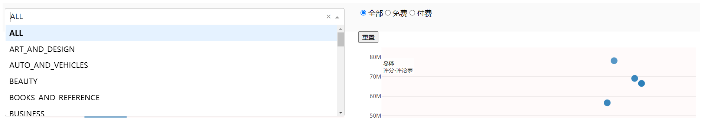

At the top of the page is a drop-down box for selecting the type of app and a radio box for selecting paid or free.

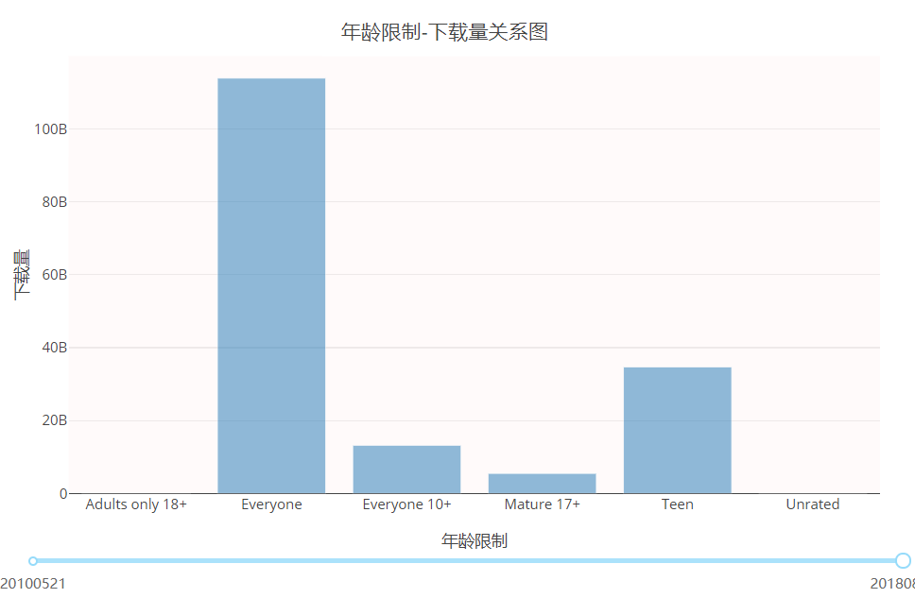

The bar chart on the left is a graph of the relationship between age-appropriateness and app downloads, with the data range changed according to the type and cost of software and the time selection bar below.

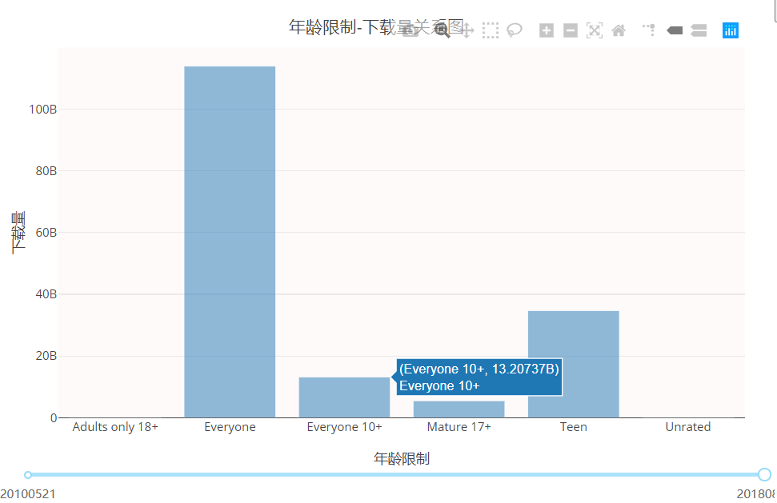

The labeling of the horizontal and vertical coordinates of the chart, the labeling of the topics, and the labeling of the types represented by the bars are all completed. When the mouse clicks on a bar chart, the information of that bar chart is displayed, and the data range of the two sub-tables on the right side is changed at the same time.

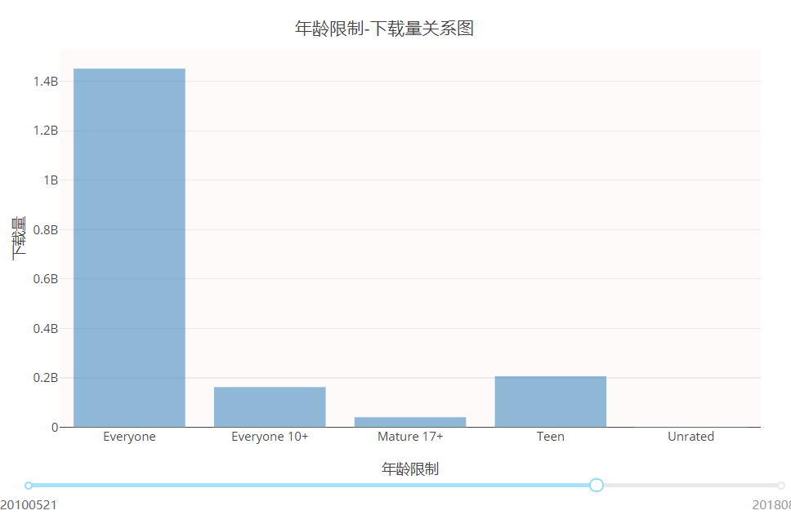

Drag the timeline to filter the software development time.

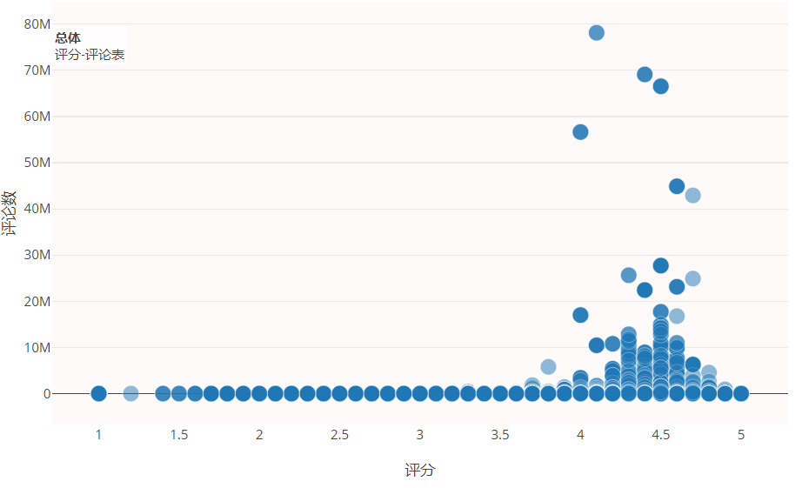

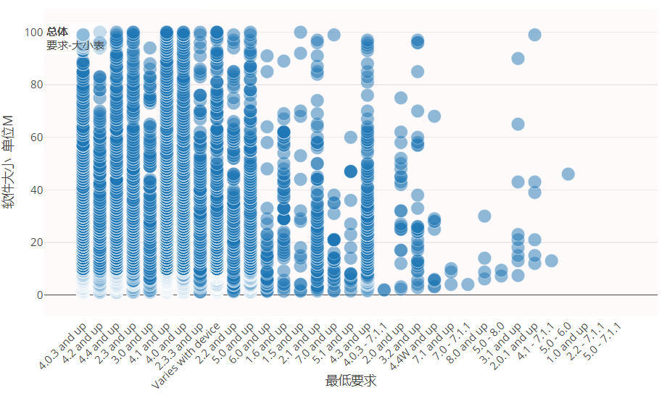

The two tables on the right side change the range of data according to the selection of the left bar chart. The default display shows data for all age-appropriate cases and changes to a specific age-appropriate range when clicked. The table above shows the rating information and number of reviews for user usage, while the table below shows the minimum system version information and software size information for user hardware requirements.



While debugging, I found that after clicking on a specific age range, the two tables above could not redisplay the information for all ages (i.e. the default range of data displayed), so a button was added to restore the default unclicked state.

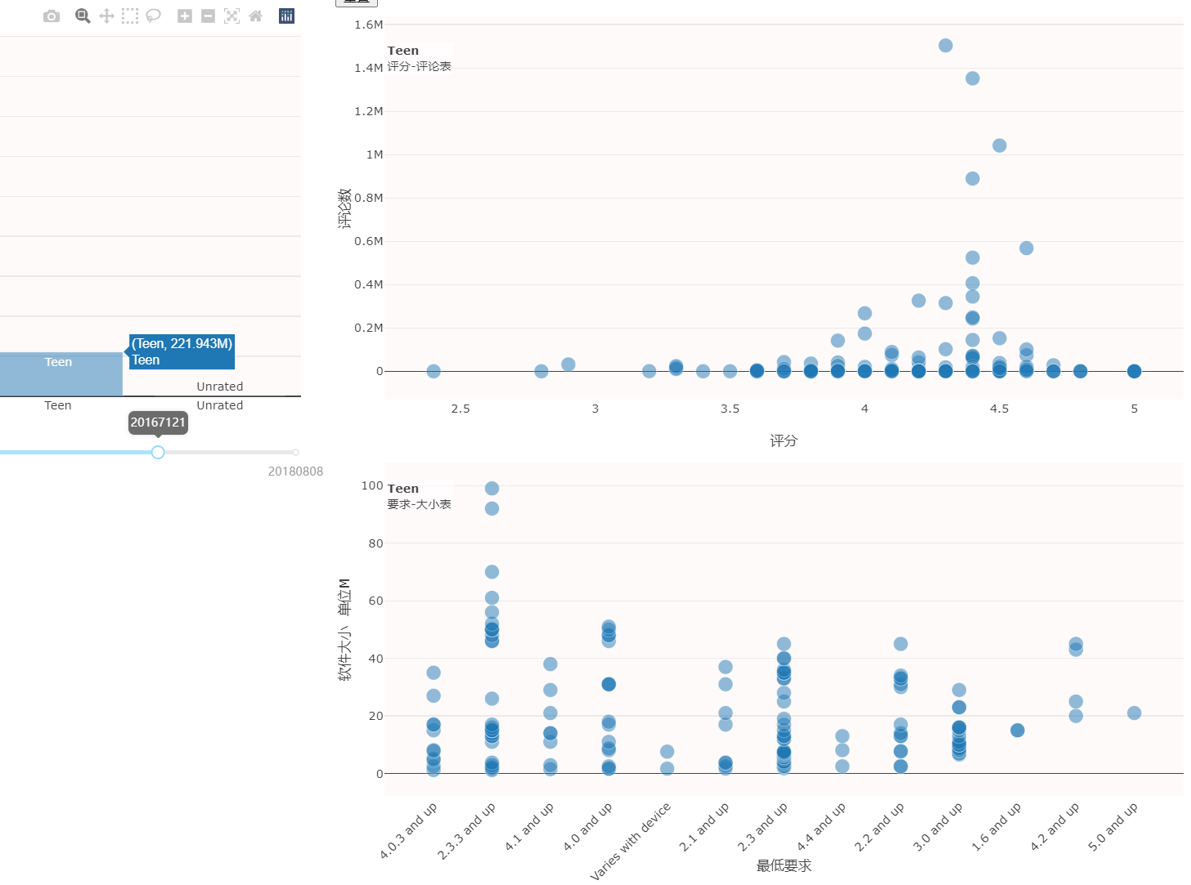

After clicking ‘Teen’, it displays as shown.

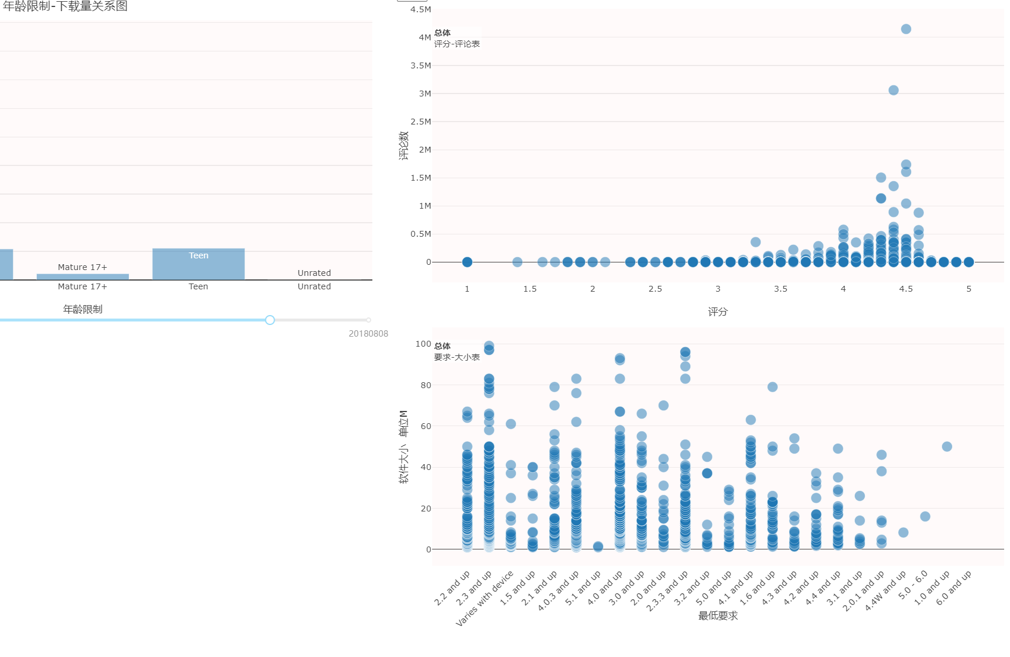

Click the button to restore the default display.

Overall project preview:

